Url Slug Suggestion - https://rootcabs.com/services/airport-taxi
Primary Keyword

airport taxi service
Secondary Keyword

airport taxi
airport transfer
airport taxi transfers
airport taxi near me
car service to airport
airport transfers near me
airport pickup service
airport taxi booking
booking airport transfers
airport transfer service
airport cab service
airport cab booking
airport cabs near me
Page Layout


Airport Taxi Service - H1
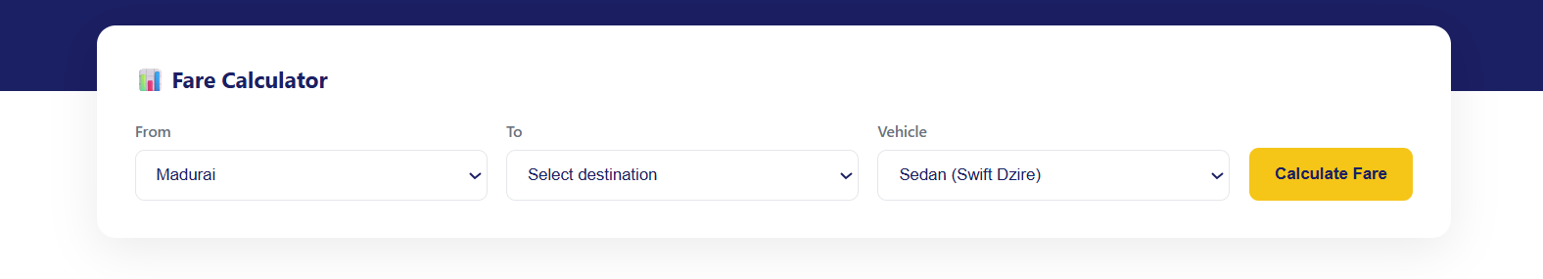
H2 - Benefits of Airport Taxi Service

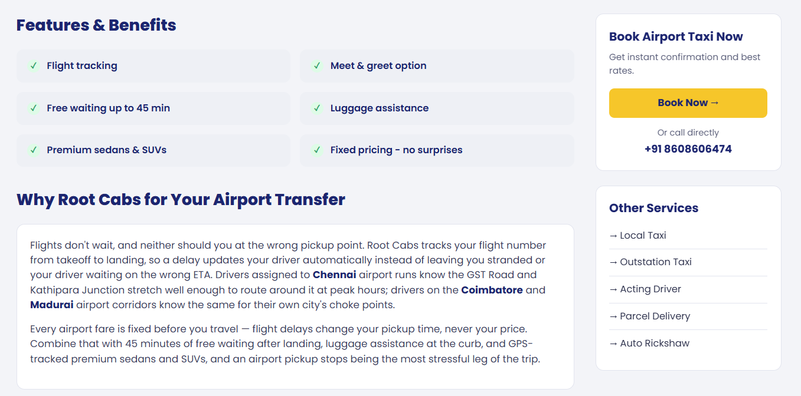

H2 - Why Root Cabs for Your Airport Transfer
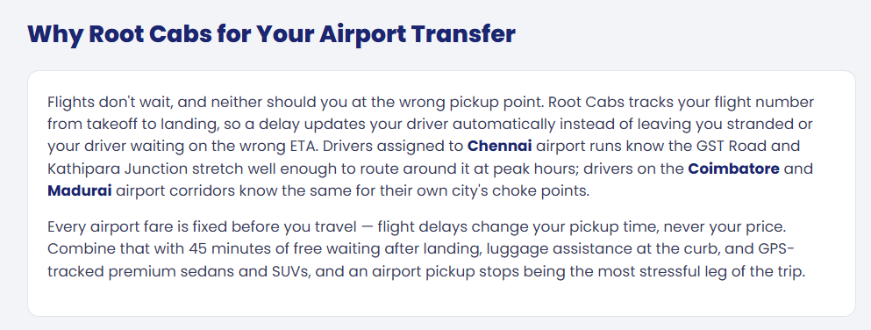

H2 - Airport Taxi Services Available In
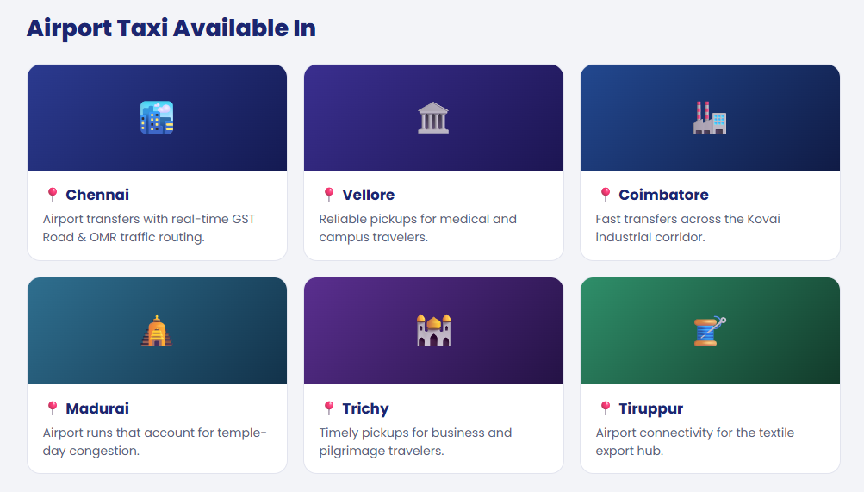
Please mention the following cities in this section: Chennai, Coimbatore, Madurai, and Trichy.
Also, please create relevant content for each city and include the following key phrases as H3 headings:
H3 - Airport Taxi Service in Chennai
H3 - Airport Taxi Service in Coimbatore
H3 - Airport Taxi Service in Madurai
H3 - Airport Taxi Service in Trichy

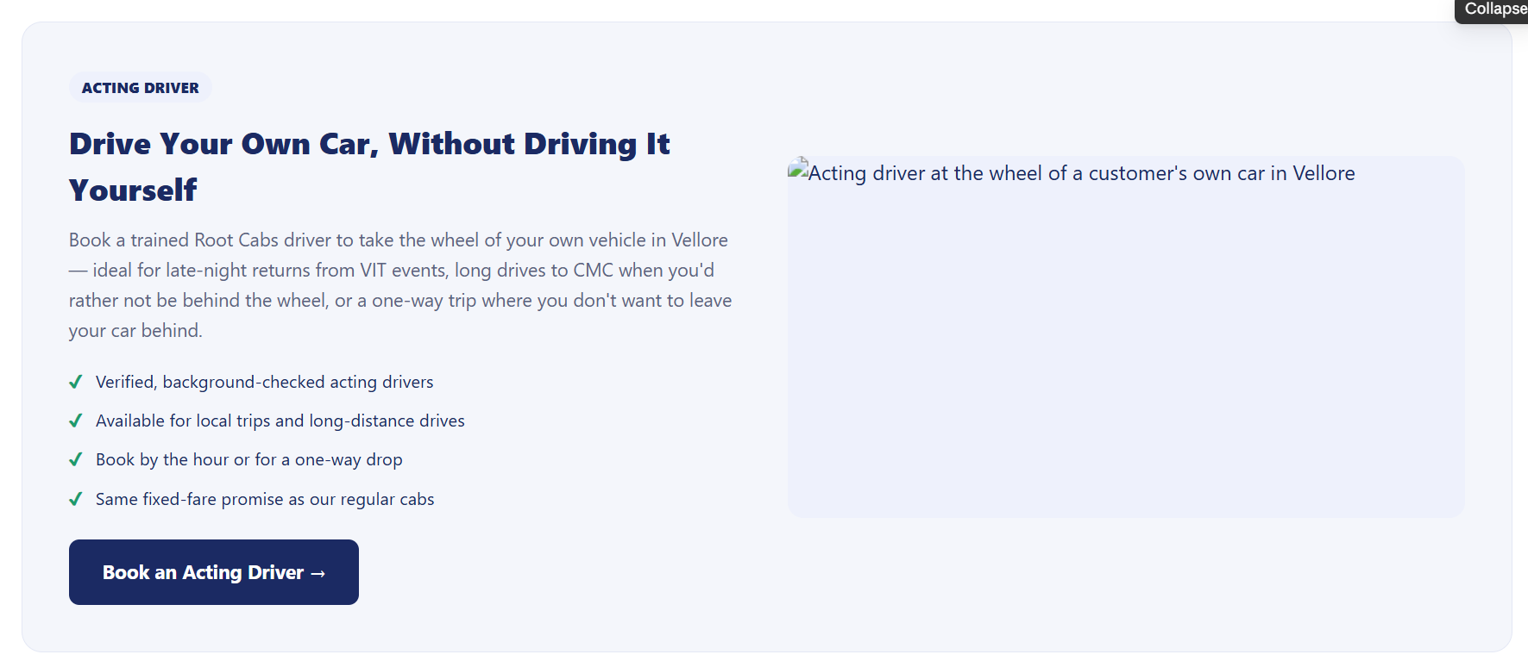

Acting driver section added - Purpose interlinking to the acting driver page.
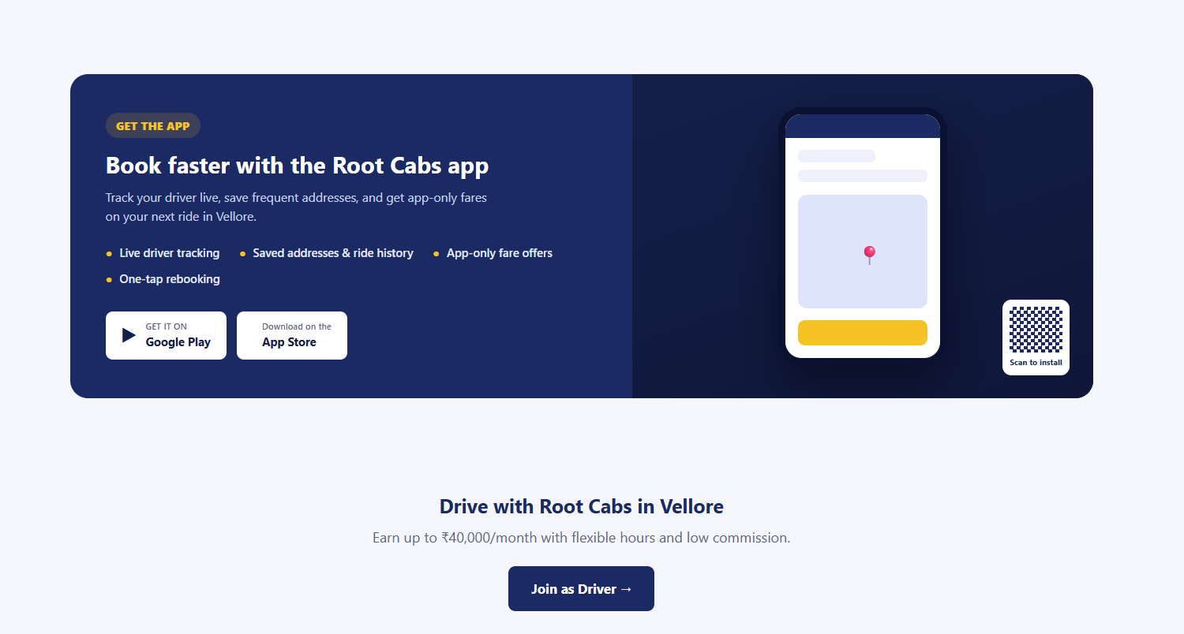

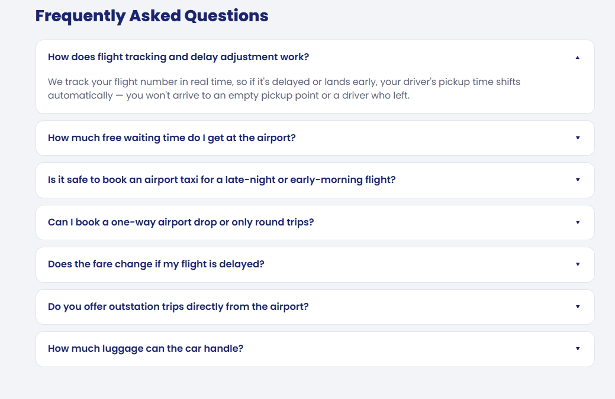
How much does a taxi cost at Chennai Airport?
How to arrange an airport taxi?
What are the cheapest airport cabs available in Tamil nadu?
How much free waiting time do I get at the airport?
Do you offer outstation trips directly from the airport?
Does the fare change if my flight is delayed?

